**Recruitment Pack**

**Administrator**

**Application Deadline:** 9am, 29th Sept 2025

**Interview Date:** 9th October 2025

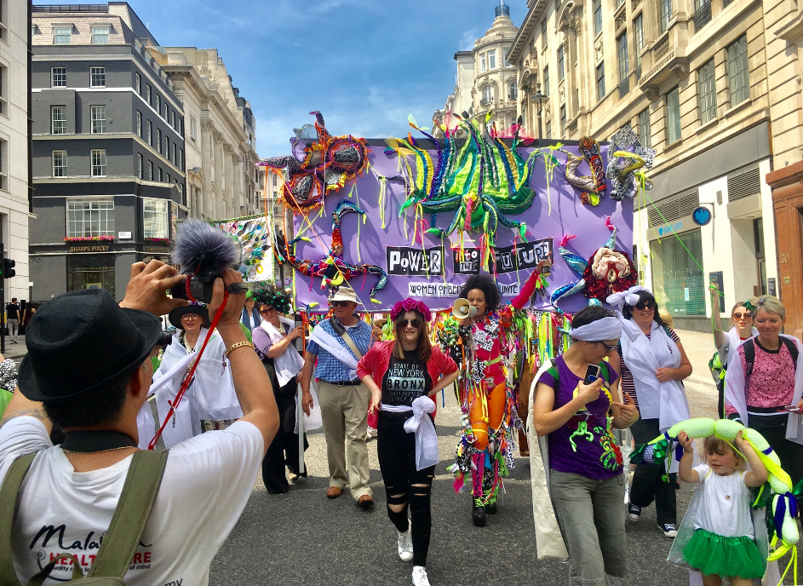

‘Processions’, (image credit: Michelle Chalkley)

Bedford Creative Arts is an Arts Council England National Portfolio Organisation.

Our Registered Charity No. is 1119555. Company Limited by Guarantee 5305188.

**About the role**

This is a new permanent position in our small creative team.

It is ideal for someone who wants to become a crucial part of an exciting, charitable arts organisation – acting as the lynchpin for our projects and processes – without needing to be a creative practitioner yourself.

**What you will be doing**

You’ll be working across all our creative projects and internal back-office systems, making sure all the paperwork, databases, correspondence and IT is in order that enables our charity to function.

Working closely with our Senior Projects Manager, you’ll make sure we document and track the development and evaluation of our work.

You’ll be researching and costing-up materials and suppliers, building surveys and databases, booking venues and arranging transport or training. You’ll make sure all our office and project equipment is looked after in our store and on our digital systems, coming up with ways to make sure we are operating as safely and efficiently as possible.

You’ll handle enquiries by phone and email, acting as the “reception” point of the charity, and will make sure that the team have the equipment and paperwork they need to ensure smooth running projects for communities.

**Who are we looking for?**

We’re looking for someone who likes the friendly nature of a small, close-knit team who are working hard to deliver creative work that benefits communities.

We need you to be highly organised and able to work independently – quickly able to understand what needs doing and able to seek the most efficient way of doing it. A confident user of Microsoft IT systems and cloud-based software, you’ll have a high-level of attention to detail and excellent communication skills.

When the rest of the team is at the coalface of community-delivery, you’ll be back at the ranch making sure the systems are organised ready for everyone’s return. Then you’ll be at the heart of planning for the next adventure.

This position is not well suited to someone who likes to be out and about at live events or someone would like to develop creative producing skills. This role is perfect for someone who wants a job they can do at a desk, through a combination of physical and virtual meetings from the comfort of their home and Bedford workspaces.

We’d love to hear from people currently under-represented in our staff team including people from UK minority ethnic backgrounds and candidates who self-identify as disabled, neurodivergent, male, non-binary or trans and/or LGBTQ+.

**Thanks for your interest.**

**Terms and Conditions**

**Hours of Work:** This position is offered for 37.5 hours per week (full-time). We are open to discussion about reduced hours and flexible working.

**Contract:** This is a permanent employment contract with a 3-month probationary period.

**Salary:** The post is offered at £26,000 per annum.

**Location:** We offer hybrid working.You will be required to work from home or at on-site locations in Bedford Borough with a minimum of 1 day per work worked in our co-working space. No travel expenses will be provided for travel between your home location & Bedford Borough (commuting).

**Benefits:**

* BCA offers 25 days (5 weeks) holiday per annum plus bank holidays.
* We offer a NEST pension scheme with a 3% employer contribution.
* Access to IT & equipment to enable efficient homeworking can be provided.
* Access to a desk in an open-plan co-working space can be provided full-time if homeworking is not reasonably practicable.

Proof of the right to work in the UK will be required before appointment.

**What we do**

Bedford Creative Arts (BCA) is a contemporary arts charity producing socially-engaged art projects across Bedfordshire.

***We create art (using any artform) that is for, with, and inspired by communities.***

Creative commissioning is at the heart of what we do, which is where an artwork is commissioned in response to a social objective or community need.

We also support our local peers through advice, mentoring & partnership to develop a thriving cultural ecology for Bedfordshire and work intensively in the education sector to inspire young people and schools to engage with culture.

News News News (image credit: Andy Willsher)

Our projects explore issues of social justice, challenge the status quo and raise questions that have the potential to influence practice and policy-making.

We work predominantly in Bedfordshire but strive for our activities and learning to make a national impact on the sectors where we work and the world in which we live.

You can read about our programme on our website: [www.bedfordcreativearts.org.uk](http://www.bedfordcreativearts.org.uk)

Each year we work with around 20 artists commissioning new works and activities that reach audiences of up to 20,000 per annum.

We are a National Portfolio Organisation (NPO) of Arts Council England and have been funded by a range of local and national funders including The Harpur Trust, Paul Hamlyn Foundation and the National Lottery Heritage Fund.

**Our Vision**

Our vision is that future communities will have **an outrageous sense of entitlement to the arts** because of its power as a tool for positive social change.

**Our Mission**

We create art for, with, and inspired by communities.

We:

**People**  - Put people at the heart of our work, working responsively and collaboratively with communities.

**Place**  - Support place-making, shaping and enriching by helping communities to have a sense of identity, belonging, agency and pride in where they live.

**Power**- Support communities to use their power to provoke change, champion social and environmental justice, and strive for a just & equitable society

**Possibility** - Seek to ask questions and have conversations that challenge the status quo, support meaningful debate and enable radical ideas to be explored.

**Practice** - Use socially engaged artistic practice to develop knowledges, skills and tools that can be shared and used nationally.

**Strands to our work**

Airship Dreams: Escaping Gravity (image credit: Andy Willsher)

**Commissioning**

We commission artists to create new work with, in, and for, local communities. This is done through any artform. We focus on social engagement through the arts by working closely with communities which can involve co-commissioning, active participation and co-creation. We often work with those who don’t normally engage with the arts.

We aim to tackle issues of local importance and seek a wide audience for our work – working predominantly in Bedfordshire but sometimes nationally or internationally. We also have considerable experience of working in cultural education, often commissioning work with and for schools and colleges.

Partners we have collaborated with include Bedford Borough Council, the University of Bedfordshire and the Bedfordshire Youth Offending Service. Recent projects have worked with local refugees, those living in deprived wards of Bedford and working with primary aged children.

Artists we have worked with include Sam Williams, Quilla Constance, Paul Pibworth, Andy Holden, Mira Calix, Caroline Wendling, Anne-Marie Abbate, Julie Myers, Maria Anastassiou, Chris Dobrowolski, Talia Giles, Bern O’Donoghue and LegalAliens.

**Creative Ecology**

Beauchamp ‘imagined futures’ day (image credit: Cat Lane)

We recognise that as a publicly funded organisation with significant experience we have a duty to develop the creative ecology in Bedfordshire. This means that we take an active and leading role in supporting networks, consortiums and talent development for artists, producers, communities and organisations in Bedfordshire.

We run a Producer Hub for Bedford with our partner, 1 Degree East that mentors and supports local producers and self-producing artists to develop their skills. We are also co-founders of the free practitioner network, Creative Bedfordshire, regularly delivering networking and skills sharing events for our creative community.

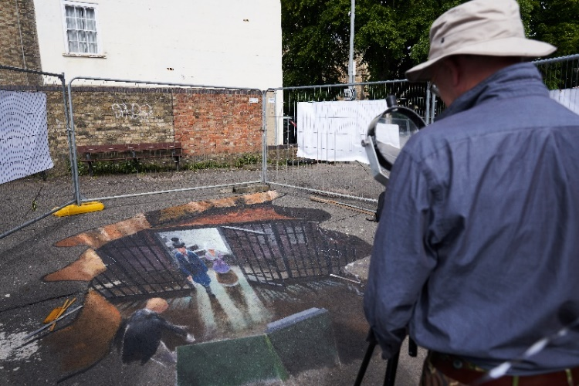

The Vault 3D mural (image credit: Andy Willsher)

**Our staff team**

BCA is a small team led by the Director, Elaine Midgley.

We have two senior managers (Programme Producer & Senior Projects Manager) who drive the artistic programme supported by a team of mostly part-time producers, managers and support staff that deliver our year-round programme of project work. We contract and expand our team to accommodate our programme, working with additional producers and project managers as required.

This post is lined managed by Bex Foskett, Senior Projects Manager.

Profiles of our staff and current Board Members can be found at: <https://bedfordcreativearts.org.uk/who-we-are/our-team/>

**Our Values**

We are a small team that works closely together to succeed in our work.

We are looking to hire people to share our values and beliefs:

**Inclusivity:** We welcome people from all backgrounds through our language and behaviour in order to embrace diversity.

**Trust:** We are open with each other and create an honest environment by behaving in a respectful and accountable manner.

**Care:** Compassion and empathy are integral to the dynamics of our team, enabling supportive and kind collaboration.

**Quality:** to achieve excellence we are committed to adapting and innovating.

**Develop:** We help staff members to realise their potential by empowering each other to grow and learn.

**Advocacy:** We individually advocate for freedom and social justice by respectfully questioning the world around us and keeping abreast of a constantly changing world.

**Staff Structure Chart**

**Job Description & Person Specification**

**Job Title:** Administrator

**Reports to:** Senior Projects Manager

**Line reports:** None

**Salary Band:** Officer

*It is our intention that this job description is seen as a guide to the major areas and duties for which the employee is accountable. However, the employee’s obligations are bound to vary and develop, so the job description should be seen as a guide and not as a permanent, definite and exhaustive statement.*

# Job Purpose

The post will provide administrative support to the charity’s artistic projects while also supporting the organisation’s office and general management functions. Working closely with the Senior Management team, this role ensures the smooth and efficient delivery of creative projects, alongside maintaining essential administrative processes that underpin the organisation’s wider operations.

# Duties and Responsibilities

|  |
| --- |
| **Project Administration** |
| **Duties & Responsibilities** |
| * Produce & maintain project documentation as required by producers and the Senior Projects Manager, such as project logs, databases, correspondence, photo permissions, surveys etc. * Undertake research to support project activity such as researching suppliers, scoping locations for project work etc. * Researching, costing & ordering materials. * Manage and maintain the company’s CRM system, including handling information on artists, audiences and venues such as contact details * Support event management including booking venues, arranging transport, preparing equipment etc, with support of Senior Projects Manager * Assist in the collation and reporting of audience, environment and participation data for evaluation of projects in line with funder and organisational requirements * Ensure maintenance of the company store & equipment, handling inventory logs and maintaining supply of key materials.   Support contract issuing for artists and contractors.   * Support marketing functions, such as occasional support for social media posting, print production and website updating. |
| **General Company Administration** |
| **Duties & Responsibilities** |
| * Coordinate routine HR admin e.g. setting up new starters including contracts, timesheets, onboarding, DBS checks, manage staff training records, supported by the Director. * Handle administration of the company’s co-working spaces & desk arrangements * Maintaining the Policy log of corporate policies. * Manage the company’s Data Audit systems for compliance with GDPR. * Arranging staff activities including training and conference attendance and team-building events (e.g. booking courses & arranging transport and accommodation) * Supporting staff & Board recruitment (e.g. scheduling interviews etc.) * Scheduling meetings including project, internal & Board meetings, including taking notes * Handle routine enquiries e.g. phone calls, emails and act as the first point of call for external enquiries. * Support the management of company overhead budgets - processing income and expenditure & handling receipts and expenses. * Handling software licences and IT & telecoms maintenance * Handling company contracts and renewals for ongoing services (e.g. web domain, insurance) |
| **Compliance & General** |
| **Duties & Responsibilities** |
| * Maintain a professional relationship with colleagues and external stakeholders at all times and ensure confidentiality and security of company business/information.      * Be completely familiar with all operational aspects of equipment and processes in your area of responsibility and request training if necessary.      * Be aware of and comply with all relevant company policies and procedures * Uphold the organisation’s values including ambition, relevance, inclusivity and environmental sustainability. * To be flexible and able to travel to other locations to attend meetings as required. * To consistently and proactively champion the organisation’s mission and values and especially its approach to an inclusive and equitable organisation that embraces diversity |

**PERSON SPECIFICATION**

This table lists things you’ll need to know to be able to do this job, as well as the skills, values and behavioural traits you’ll need to have.

If we think this role will need to be solely responsible for areas of work, or we have limited resource for training and supervision, we’ll also expect you to have experience of some areas of work that demonstrate that you are confident doing certain things.

We will score how well your application demonstrates a fit against these criteria. If you do not score highly on all ‘essential’ criteria, you are unlikely to be called for interview.

|  |  |
| --- | --- |
| **Knowledge** | **Essential or Desirable** |
| Excellent spoken & written British English | Essential |
| Basic knowledge of Maths & using numerical data | Essential |
| Good ITC knowledge – in particular Microsoft Office/365, email and cloud-based software such as Sharepoint, Dropbox etc. | Essential |
| Knowledge of databases | Essential |
| Knowledge & understanding of the arts sector in the UK | Desirable |
| Interest in art in any relevant artform/s | Essential |
| Knowledge of Bedford and the surrounding area(s) | Desirable |
| Knowledge of UK data protection laws and best practise | Essential |
| Knowledge of corporate HR processes | Desirable |
| Knowledge of AI for administrative processes, including both risks and benefits | Desirable |
| **Experience** | |
| Handling administration using MS365 tools such as correspondence, producing documents, building databases, creating forms etc | Essential |
| Working in an office environment | Essential |
| Working remotely, such as from home | Essential |
| Working in a team | Essential |
| Undertaking research both online and via phone/practical enquiry | Essential |
| Handling enquiries from members of the public by phone and email | Essential |
| Administering contracts | Desirable |
| Organising meetings including calendar scheduling, taking meeting notes etc | Essential |
| Using digital marketing tools including website CMS systems and social media | Desirable |
| **Abilities, Values, Skills & Competencies** | |
| Excellent communication skills including using both informal and formal tones in written and verbal communication | Essential |
| Excellent IT accuracy and attention to detail with data entry, typing, proofing etc | Essential |
| Organised and efficient, able to successfully manage their own workload | Essential |
| Good time management, able to meet deadlines & prioritise work | Essential |
| A presentable and professional manner | Essential |
| Must be able to work alone and use initiative | Essential |
| Works well under reasonable pressure & with multiple tasks | Essential |
| Demonstrates high standards of customer service to clients and colleagues | Essential |
| Ability to work effectively in an open-plan office environment alongside others | Essential |
| Ability to work effectively away from the office (e.g. working from home) under own initiative | Essential |
| Able to work as part of a team and build rapport with others | Essential |
| Proactive and keen to offer ideas & constructive views | Essential |
| Strong personal commitment to the principles of equality & diversity | Essential |
| Demonstrates a strong commitment to the organisation’s mission and values | Essential |

**How to apply**

To apply for this role please send a CV (description of your relevant work experience, qualifications and skills) and a covering letter (no more than 2 sides of A4) outlining why you think you are suitable for the role to [office@bedfordcreativearts.org.uk](mailto:office@bedfordcreativearts.org.uk)

You can provide this information in a written format, **or** as an audio or video file (no longer than 5 minutes) if you prefer. If you need to provide it in a different format, please let us know what would suit you.

Please ensure your application contains:

* Personal contact details
* Details of your current employment, if any
* Dated employment history (job titles, duties & name of employer)
* Details of your education & any relevant training
* Names of two professional referees (referees will not be approached before selection or without your permission but we’d like to see who you choose)
* The reason why you want the job

Please note: your application will be scored against the Person Specification for the role. Please ensure you demonstrate how well you fulfil the Person Specification in your application.

Please also include a completed Equal Opportunities Monitoring Form, available separately. This is simply to help us review how ell we’re reaching a wide range of people. It is anonymous and will not be used to score your application.

The application deadline is **9am on Monday 29th September 2025,**

For an informal and confidential conversation about the role please e-mail or call Bex Foskett on 01234 818670 or [bexf@bedfordcreativearts.org.uk](mailto:bexf@bedfordcreativearts.org.uk)

**Interviews**

Initial interviews will likely be held on or around **Thurs 9th October 2025**.

Interviews will be held in person in Bedford.

Second stage interviews may be required.

If you have any additional access needs at the interview stage, please inform us when you are invited to interview.

**Thank you for your interest in working for Bedford Creative Arts**

**Privacy Notice**

Bedford Creative Arts (BCA) complies with the Data Protection Act 2018 and the General Data Protection Regulation (EU) 2016/679 under the control of its Information Governance Policy. Your information will be stored confidentially and only be used for the purposes of selection and recruitment for the role applied for. Your information will not be transferred outside the organisation. By submitting an application, you are indicating that you are content for your details to be stored by BCA for the purposes of handling this recruitment process until such time as an appointment is made. After appointment, all application information will be safely destroyed unless you give us permission on contact to retain it in our Talent Bank for the purposes of informing you about other future employment opportunities which may be of interest.

**Equal Opportunities & Diversity**

Bedford Creative Arts is an Equal Opportunities Employer which means that all applications will be judged on the candidate’s individual merit and abilities in relation to the job description for the role and no applicant will be unfairly discriminated against on the basis of any protected characteristic (as defined by the Equality Act 2010) or will be disadvantaged by conditions or requirements which cannot be shown to be justifiable.

We actively encourage people from a variety of backgrounds with different experiences, skills and stories to join us, and influence our working practice. We are particularly keen to hear from people from UK minority ethnic groups and candidates who self-identify as disabled, neurodivergent, male, non-binary, trans, and/or LGBTQ+ as these characteristics are under-represented on our staff team presently.

For more information about our company policies, please visit:  
<https://bedfordcreativearts.org.uk/policies/>