Artist Brief: Light Installation Artist Required
‘Love Kempston’ Light Walk
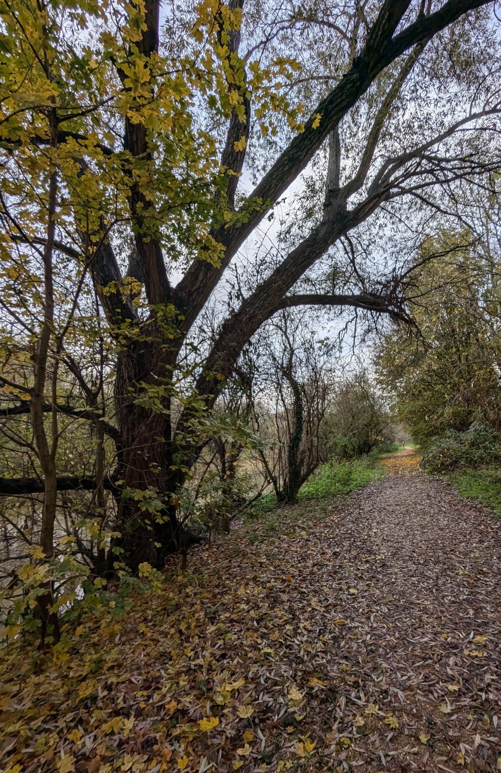
Summary

Bedford Creative Arts (BCA) is looking for an experienced artist to create light-based installations for an outdoor community ‘Light Walk’ on the 15th March 2025.

The walk will be a small-scale event at dusk along the river in Kempston, Bedford. It will be first event of its kind in the area.

The ‘Love Kempston Light Walk’ is part of a project called River/ Flow/ Connect which aims to use a series of creative activities with the communities of Kempston to connect residents with the River Great Ouse on their doorstep.

The Brief

Bedford Creative Arts are looking for an exceptional artist specializing in public outdoor events to deliver between 5-10 temporary light sculptures/installations as part of a family-focused enchanted light walk.

We have no access to power so these structures would be solar or battery-operated.

The walk is approximately 40 minutes in length along the banks of the River Great Ouse between Kempston Mill (Mill Lane, Bedford, MK42 7FB) and Sanders Close (approx. MK42 8RX) – an area known as the Kempston Riverside Path. We expect the total event running time to be approximately 3 hours.

The selected artist would reference local knowledge and use the community research we have collected through our previous community workshops and events to inform the artworks.

See Appendix 1

The site includes the Robin’s Tree Stump, The Swan, The Old Oak, The Twin Trees and The Willow Archway.

To learn more about our wider project visit:
https://bedfordcreativearts.org.uk/projects/river-flow-connect/

The artist will have significant experience in creating temporary artworks in the outdoors relating to the local environment, a passion for the river environment and community-engaged public art.

Fee

The fee is in the region of £1,250-£1,500.

There is a separate budget available for materials held by BCA of £500 (max).

Reasonable travel expenses will be provided and agreed in advance.

This is a freelance contract. The artist will be liable for their own tax, insurance and pension contribution. This is not an employment contract.

Application Process

Candidates wishing to apply should submit an outline proposal of no more than 2 sides of A4 explaining how they will respond to the brief and outlining the following:

- Their relevant experience.
- Examples of previous work or links to these online.
- How they will approach the brief (ideas do not need to be worked up in detail but we need to understand the type of work that’s likely to be created).

We will obtain references from the successful candidate before appointment.

Artists are welcome to supply this information in video or audio format (no longer than 5 minutes) if they prefer. If you require any other support to apply, please contact us to discuss how we can support your application.

For informal enquiries, please email our Programme Producer, Ami Aubrey, amia@bedfordcreativearts.org.uk before the 31st December 2024.

We welcome joint applications or applications from artist collectives.

Deadline for applications 11am, Monday 20th January 2025

Please submit applications to: office@bedfordcreativearts.org.uk

Eligibility
We welcome applications from artists at various stages of their career and from a variety of demographic backgrounds.

An Enhanced DBS check w be required for any unsupervised work with the community; however this is not anticipated.

About Bedford Creative Arts

Bedford Creative Arts is a contemporary arts organisation that has worked across Bedfordshire for 39 years. It is committed to commissioning high quality art in communities, working with people to make great art in response to the place where they live. We work at different levels, from light participation to deeper collaborative projects between artists and the public. Throughout our work we seek to make new work that is accessible and engaging for audiences and questions and develops social practice within contemporary art. Bedford Creative Arts is an Arts Council England national portfolio organisation.
www.bedfordcreativearts.org.uk

About River/ Flow/ Connect

River Flow Connect is a longitudinal project that aims to strengthen engagement and connection with the River Great Ouse by residents living near the riverbank between the town centre and Rural Kempston/ Great Denham. Beginning firstly in Kempston, the project seeks to use arts and creativity as a tool for helping residents to have a positive relationship with their local river that sees an increase in use of the riverbank as a place for recreation, navigation by foot and cycle, socialisation and conservation.
To do this we will identify locations along the riverbank that will be transformed into accessible community spaces (“hubs”). A “hub” is likely to be where we restore an overlooked open-space and re-claim it for use by residents as an area to picnic, walk along, cycle along and celebrate at. This Kempston phase of community engagement is funded by the National Lottery Community Fund, Bedford Borough Council and Arts Council England.

About Kempston

Kempston is a large town within Bedford Borough with a strong Parish identity. Three key wards are linked along the river area for this project and ward councillors are actively engaged. Some areas have higher levels of need for the Community Needs Index than for the rest of Bedford (the Community Needs Index identifies areas experiencing poor community and civic infrastructure, relative isolation and low levels of participation in community life.). Levels of deprivation are generally higher than average for England and for wider Bedford and levels of Higher Education are lower. Some areas also have a higher than England and Bedford average levels of disability.

Equal Opportunities

Bedford Creative Arts values inclusivity and strives to ensure equal opportunities for all. This means that all applications will be judged on the candidate’s individual merit and abilities in relation to the brief for the role and no applicant will be unfairly discriminated against based on any protected characteristic (as defined by the Equality Act 2010) or will be disadvantaged by conditions or requirements which cannot be shown to be justifiable. We acknowledge certain demographics are often under-represented in the arts and in our areas of work and therefore we especially encourage applications from diverse ethnic backgrounds, those with a disability, and those with less formal educational qualifications. We will not prejudice any applicants that do not come from one of these backgrounds if they have the skills and knowledge needed to deliver the role however, we may take positive action to support representation where this can be shown to be justifiable. If you require an alternative method of application in order to fairly access this recruitment process, please contact us on info@bedforcreativearts.org.uk or 01234 818670.

Privacy Notice

Bedford Creative Arts (BCA) complies with the Data Protection Act 2018 and the General Data Protection Regulation (EU) 2016/679 under the control of its Information Governance Policy. Your information will be stored confidentially and only be used for the purposes of selection for the role applied for. Your information will not be transferred outside the organisation. By submitting an application, you are indicating that you are content for your details to be stored by BCA for the purposes of handling this recruitment process until such time as all appointments are made. All application information from unsuccessful applicants will be safely destroyed unless you give us permission to retain it in our Talent Bank for the purposes of informing you about other future opportunities which may be of interest.

Appendix 1
Potential sites for artist light interventions along the path:

Archway

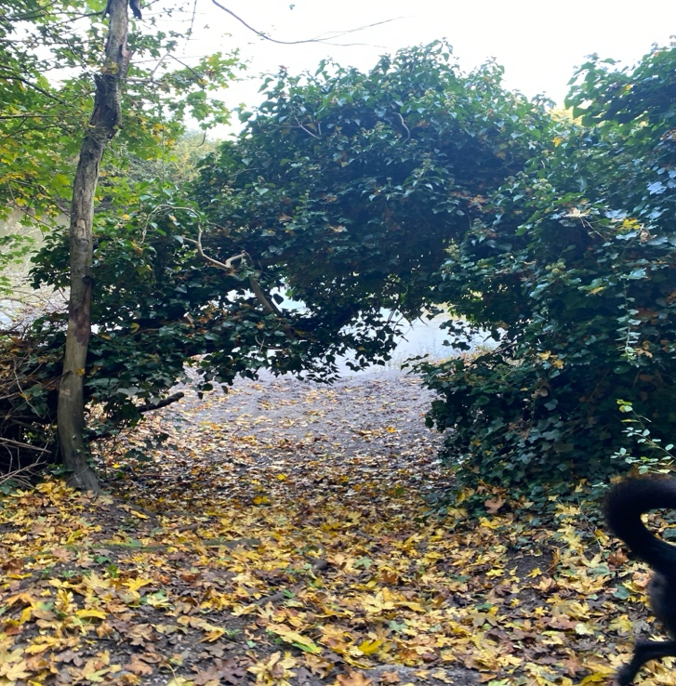

Yellow Steps

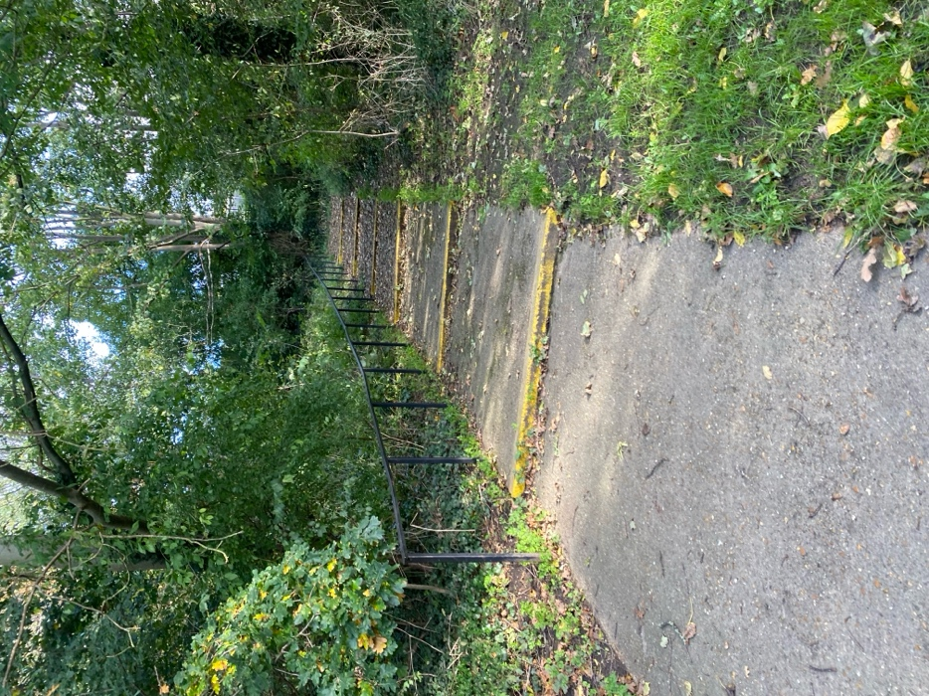

Steps 2

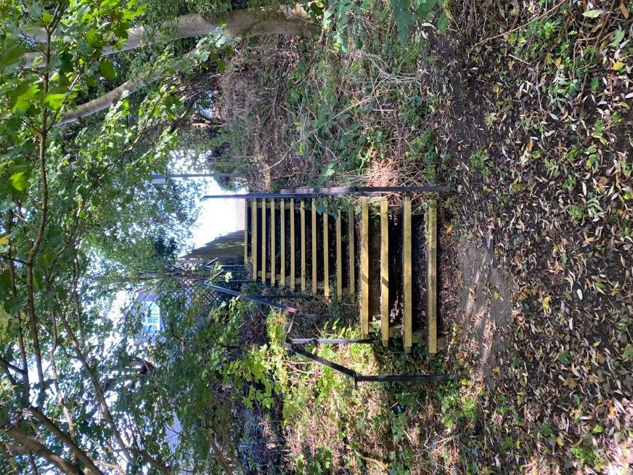

Willow

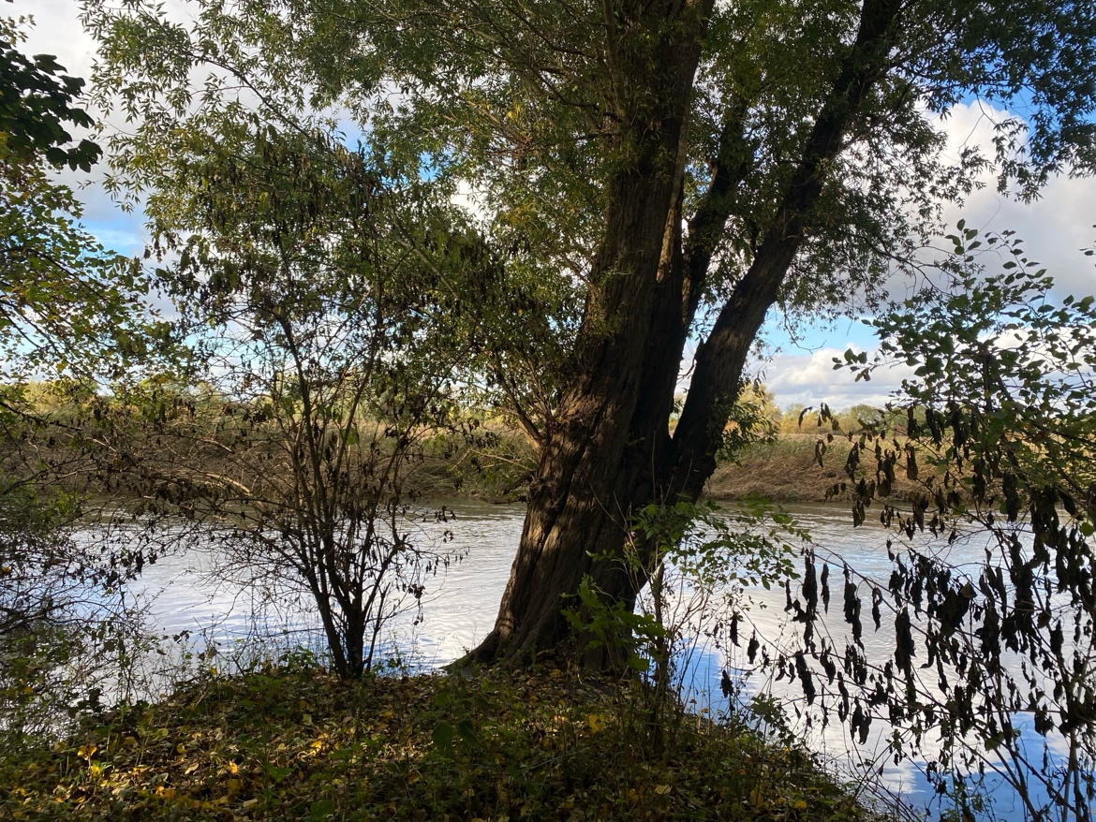

Robin Tree Stump
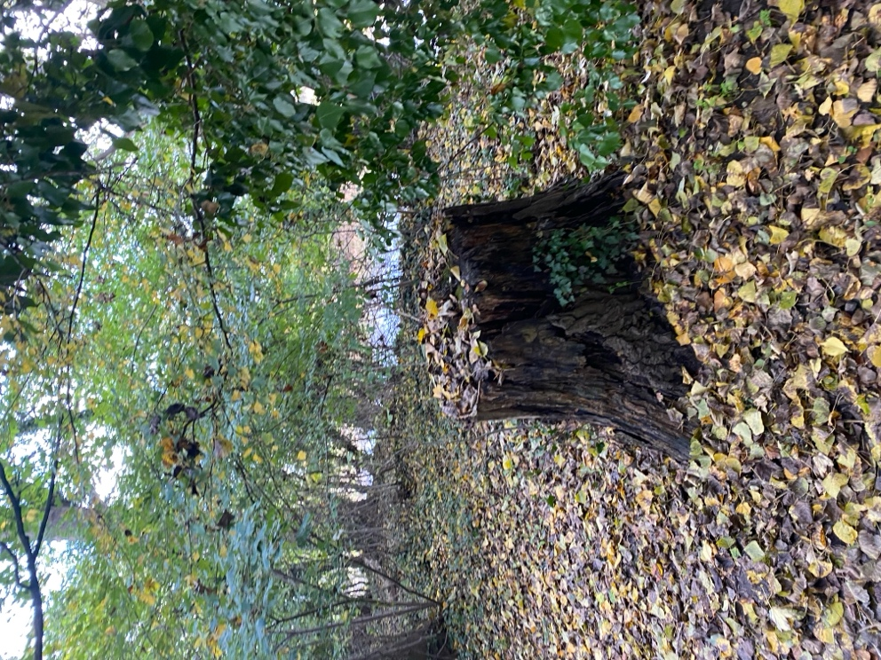

Old Oak Tree

