Underpass Mural: Artist Brief
Exterior Mural Artist Required
About the Project
Bedford Creative Arts (BCA) has been commissioned by Bedford Borough Council to re-paint a mural on the subway/underpass between The Embankment and Aspects Leisure Park in Bedford town centre (what3words reference: gallons.punchy.nature).

There is currently a mural on two walls that depicts a riverside scene. This project will paint over the existing mural and extend a new design onto the ceiling, walls and entryways walls to the underpass (currently painted white).

The mural will be painted with support from local volunteers recruited through the Bedfordshire Youth Offending Service to help them to have ownership of the mural. These young people will also have the chance to have some advance painting workshops to learn painting techniques.

The painting will ideally take place in February 2025 (subject to weather and artist availability). Proposed delivery week commencing 3rd of February 2025. The project needs to be competed and evaluated by 31 March 2025.

The project is funded by Bedford Borough Council and funding awarded by BLCF as part of the Safer Bedfordshire Community Fund.

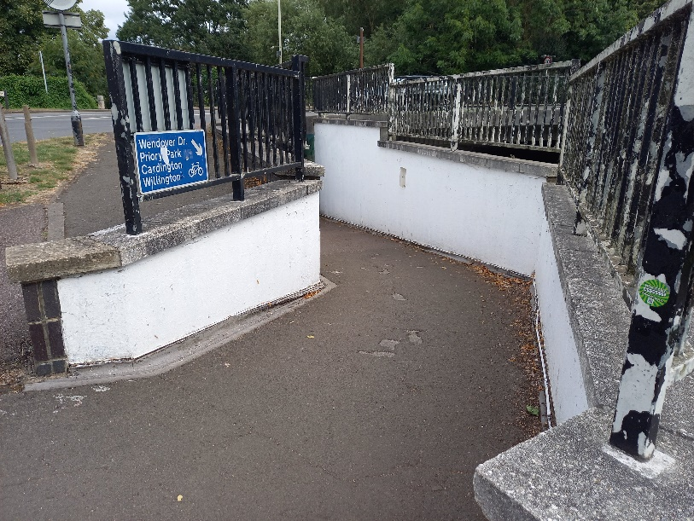
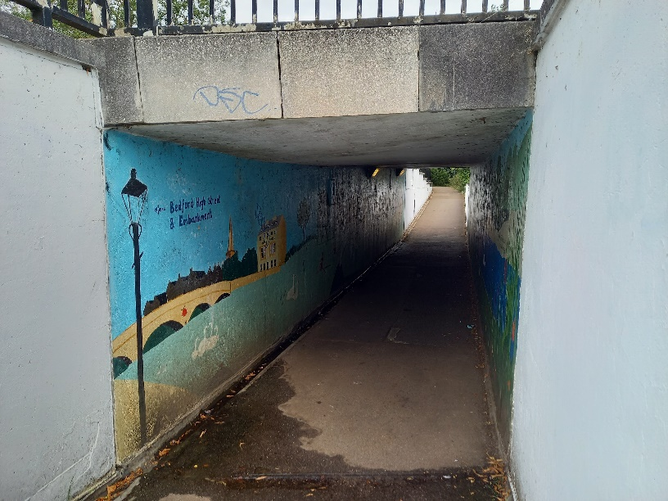

Desired Project Outcomes

- Residents feel happier & safer using the Underpass and are more encouraged to use it. They will have pride in the art and feel it enhances their sense of belonging and positivity to the local area.

- Young people including those referred from the Beds Youth Offending Service become more aware of how graffiti and anti-social behaviour can have a negative impact on residents and how, conversely, a positive activity can have the opposite effect. They will be given positive skills in art design and painting through working with a professional artist, creating a sense of pride and achievement in connection to a positive art activity.

- Council costs are reduced on having to remove graffiti and damage to the underpass and they see how positive art activity can support social outcomes for the community.

The Brief

We are looking for a mural artist who will work with BCA and the Bedfordshire Youth Offending Service to create the following outputs:
- 2 x workshop days with young people referred from the Youth Offending Service to create design ideas and learn mural painting techniques.
- Artist preparation of 2-3 designs that incorporates these ideas for selection by Bedford Borough Council and members of the Youth Offending Service.
- Painting the mural, with assistance from volunteers and young people, including any base coats and anti-graffiti coatings.

Who we are looking for

We’d like this opportunity to go to a local artist (Bedfordshire) with experience and skill in designing and delivering large-scale exterior murals in public locations. We welcome artist collaboration

The artist/s also needs to have experience of community engagement, especially young people and will be subject to an Enhanced DBS check.

We are looking for someone able to design and paint a vibrant mural that could be abstract, multi-faceted and/or have themes that relate to nature and the environment. The design needs to enable others to be part of the process of painting the mural (e.g. it might use stencils or block colours that can be marked out by the artist but completed by other painters).

Timeline
- 10am on 30th December 2024 Artist Submission Deadline
- Week commencing 6th January 2025 Artist shortlisting and interviews
- Week commencing 27th January 2025 Workshops take place with young people
- Week commencing 3rd February 2025 Preparation & painting

The painting will be understandably influenced by the weather and so dates for installation may be moved. The project must be completed fully no later than 31st March and so if weather precludes 3rd February being used for installation, alternatives will be considered.

Fee

Total fee is £2,750.00 for the planning, workshops and delivery of the mural. The fee should be inclusive of any VAT, if applicable.
This fee assumes 2 design days, 4 days of workshop activity, 5 days to deliver the mural contracted work.
This is a freelance contract. The artist will be liable for their own tax, insurance and pension contribution. This is not an employment contract.
This fee is inclusive of all labour and disbursements such as workshop preparation and travel expenses.
There is a separate materials budget available of £1,000.00 for paint and supplies, managed by BCA.

Application Process

Candidates wishing to apply should submit a proposal of no more than 2 sides of A4 including links to their work, explaining how they will respond to the brief and outlining the following:

- Their relevant experience (including their ability to work with young people and community participants)
- How they intend to deliver the outputs required
- 2 professional references

Artists are welcome to supply this information in video or audio format (no longer than 5 minutes) if they prefer.

Submissions should be sent by email to office@bedfordcreativearts.org.uk by 10am on the 30th of December 2024.

Questions may be asked in advance by email to clarify the brief using the address above.

Selection Process
Artist proposals will be reviewed by BCA and assessed for their fit with the brief and level of experience of the applying artist.

Strong candidates will be invited for a phone call or virtual interview at the end of January before appointment.

Artists who have never before worked with BCA will have their references checked prior to appointment.

Eligibility
We welcome applications from artists at various stages of their career and from a variety of demographic backgrounds. We especially welcome artists from backgrounds relevant to our project participants and beneficiaries such as those from working class backgrounds, Global Majority backgrounds or who identify as disabled, neurodivergent and LGBTQ+ or those often under-represented in the arts sector.

An Enhanced DBS check will be required for any unsupervised work with the community.

About Bedford Creative Arts

Bedford Creative Arts is a contemporary arts organisation that has worked across Bedfordshire for 39 years. It is committed to commissioning high quality art in communities, working with people to make great art in response to the place where they live. We work at different levels, from light participation to deeper collaborative projects between artists and the public. Throughout our work we seek to make new work that is accessible and engaging for audiences and questions and develops social practice within contemporary art. Bedford Creative Arts is an Arts Council England national portfolio organisation.
www.bedfordcreativearts.org.uk

Equal Opportunities

Bedford Creative Arts values inclusivity and strives to ensure equal opportunities for all. This means that all applications will be judged on the candidate’s individual merit and abilities in relation to the brief for the role and no applicant will be unfairly discriminated against on the basis of any protected characteristic (as defined by the Equality Act 2010) or will be disadvantaged by conditions or requirements which cannot be shown to be justifiable. We acknowledge certain demographics are often under-represented in the arts and therefore we especially encourage applications from diverse ethnic backgrounds, those with a disability, and those with less formal educational qualifications. We will not prejudice any applicants that do not come from one of these backgrounds if they have the skills and knowledge needed to deliver the role. If you require an alternative method of application in order to fairly access this recruitment process, please contact us.

Privacy Notice

Bedford Creative Arts (BCA) complies with the Data Protection Act 2018 and the General Data Protection Regulation (EU) 2016/679 under the control of its Information Governance Policy. Your information will be stored confidentially and only be used for the purposes of selection and recruitment for the role applied for. Your information will not be transferred outside the organisation. By submitting an application, you are indicating that you are content for your details to be stored by BCA for the purposes of handling this recruitment process until such time as all appointments are made. All application information from unsuccessful applicants will be safely destroyed unless you give us permission to retain it in our Talent Bank for the purposes of informing you about other future opportunities which may be of interest.

For further information, please contact:

Ami Aubrey, Programme Producer
amia@bedfordcreativearts.org.uk

Further Photos

Approach to interior of subway from The Embankment:

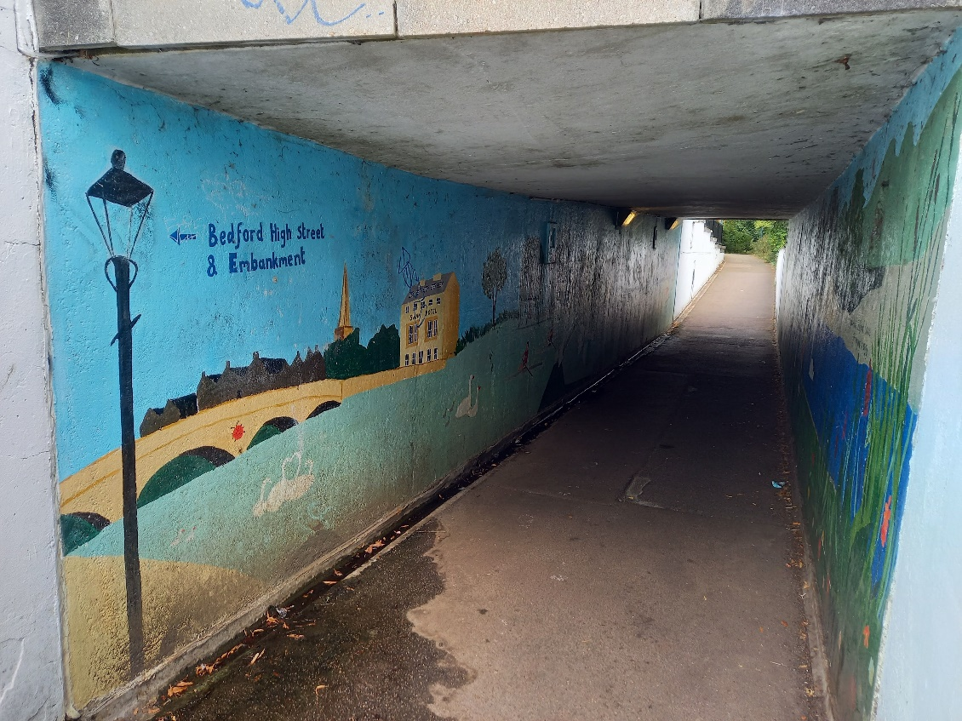

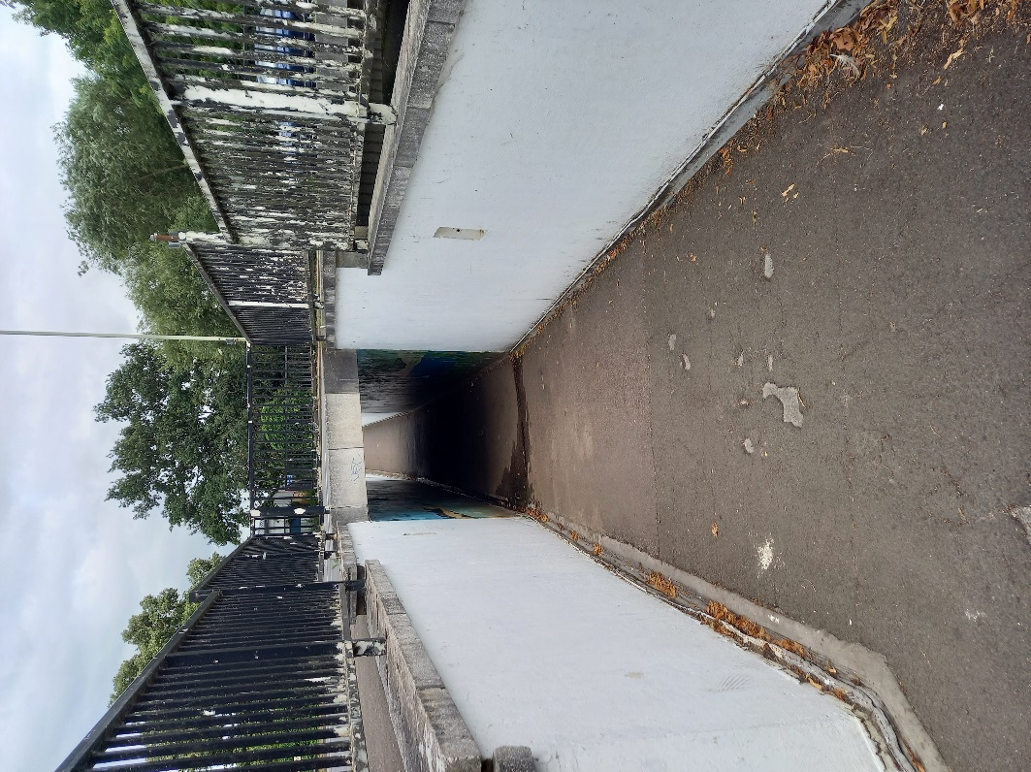

Approach from Aspects Leisure Park side:

